Ideation Phase
Brainstorm & Idea Prioritization Template

Date | 29 September 2026
Team ID | 6ab3d2b20fc666a751b3505e
Project Name | AI BlogNest API
Maximum Marks | 4 Marks

Brainstorm & Idea Prioritization Template:
Brainstorming for AI BlogNest API provides an open and collaborative environment where team members can generate and discuss innovative ideas for developing an intelligent blog management and content generation system. The brainstorming process focuses on identifying the needs of bloggers, content creators, students, and administrators and finding suitable API-based solutions.
Step-1: Team Gathering, Collaboration and Select the Problem Statement
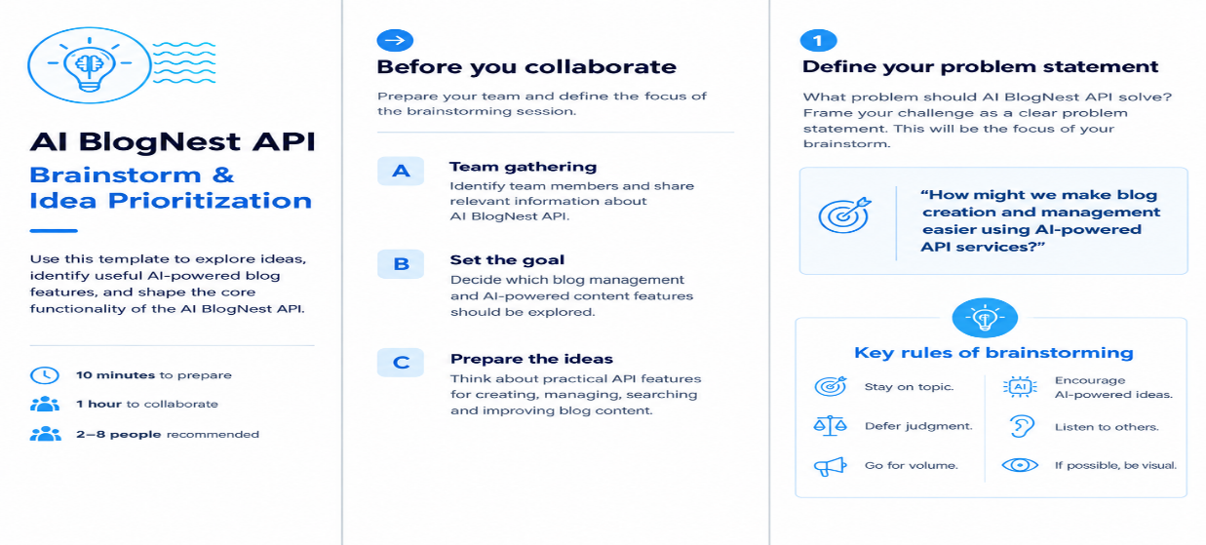

Step-2: Brainstorming,Idea Listing and Grouping for AI BlogNest API
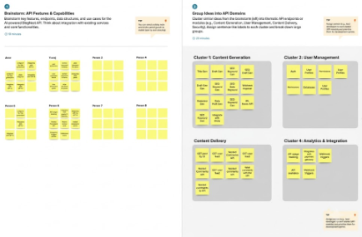

Step-3: Idea Prioritization
